IIHT Techademy: node package manager- npm

IIHT Techademy: angualr command- ng

IIHT Techademy: typescript- tsc

PS D:\Java-FullStack\Code> tsc Angular-session1.ts

PS D:\Java-FullStack\Code> node Angular-session1.js

Welcometo Java

Welcometo Java

1

PS D:\Java-FullStack\Code>

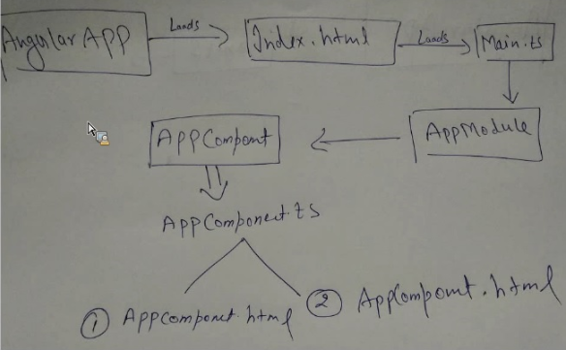

Component Lifecycle -

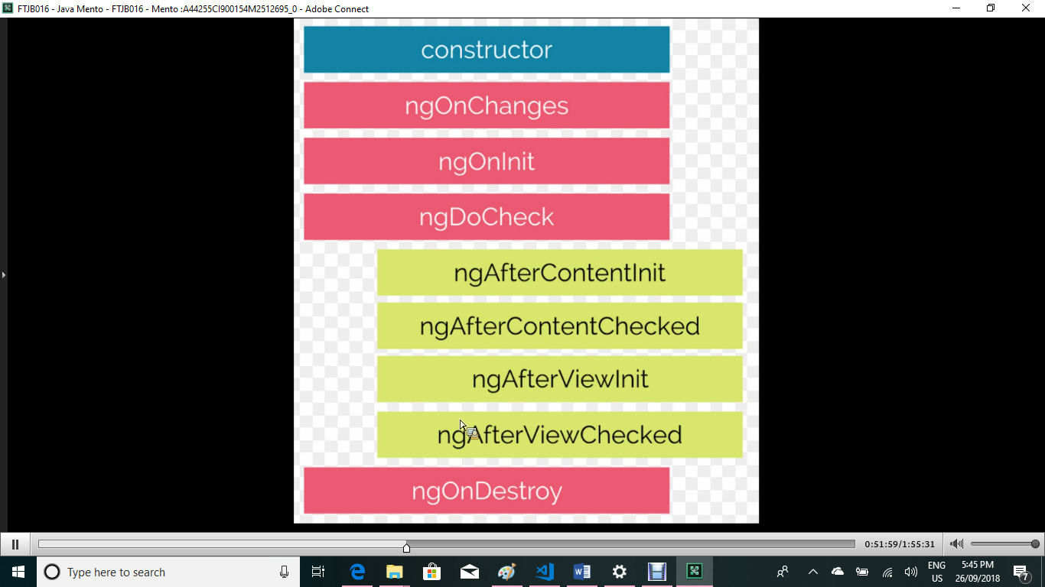

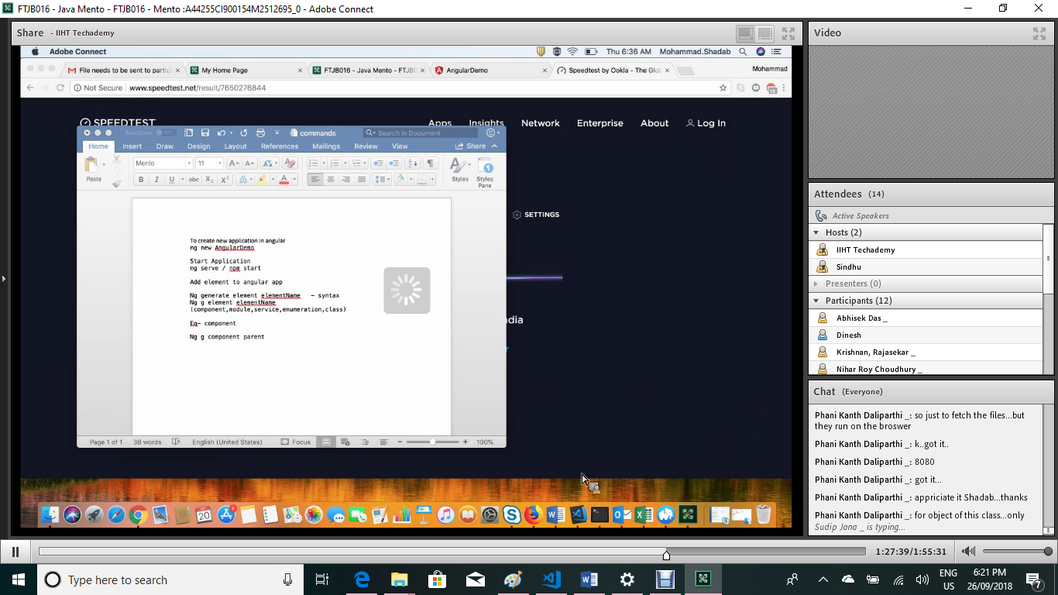

Port clean - netstat -a -n –o to get PIT of 4200

taskkill -f /pid 18932 (pit of 4200)

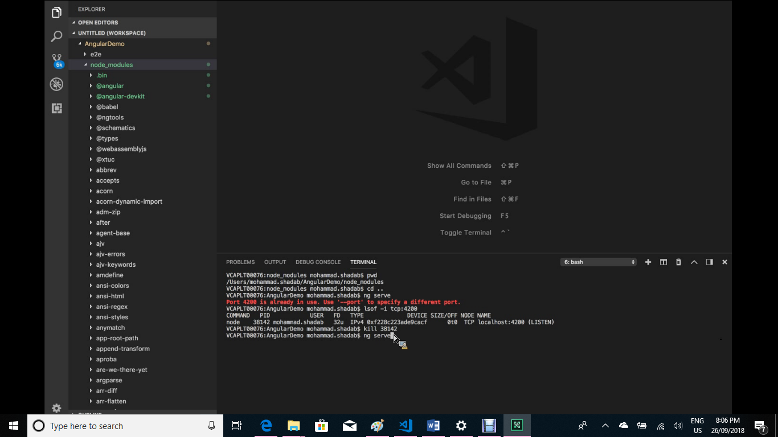

25-09-18 Angular –

<https://github.com/shdb1/AngularDemo>

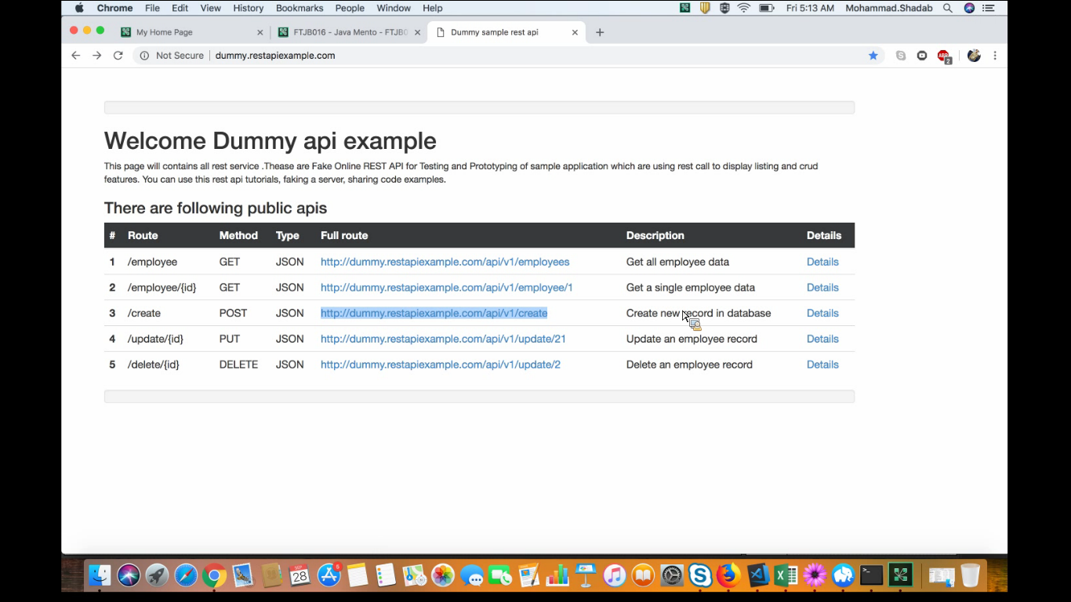

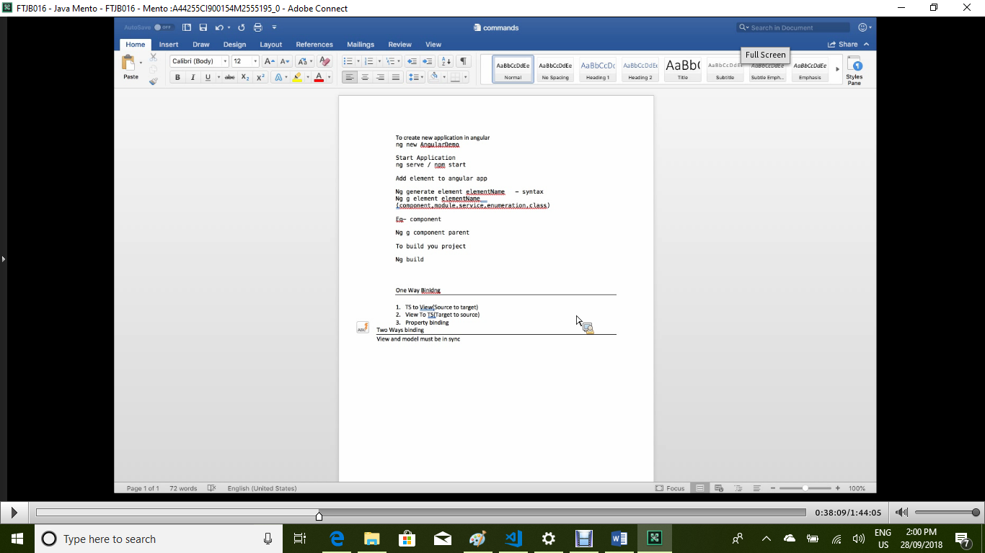

Ng generate element elementname

Ng g element elementname

Ng g component parent

Ng new AngularInteraction

Ng g d mytest -> Create directive command

Ngif/ngfor directive – 1.29/1.34/1.46/1.54/1.57/2:04 – Angular class 5

Angular class 6 – 1.28

Ng g module module-name

Npm install